Chijike Dikeogu
Professor
Narrative Design
9/12/2017
Case Study 1: “Ar nosurge: Ode to an Unborn Star”
(“A Song that Prays for A Planet Being Born-"”)
Developer: Gust
Publisher: Tecmo Koei
Designer: Akira Tsuchiya
System: PlayStation 3, PlayStation Vita
Release Date: PlayStation 3 = March 6th, 2014(JP), September 23rd, 2014(US), and September 26th, 2014(EU)
PlayStation Vita = October 2nd, 2014(JP), July 1st, 2015(EU), July 2nd, 2015(NA)
Genre: Single Player Role–Playing Game

Once upon a time, there was a unique game known for redefining and turning the concept of the fourth wall into a major driving story and game mechanic. The game in question is called “Ar nosurge: Ode to an Unborn Star” which translates to “A song that prays for a planet being born”. The game was created by a company called Gust. Gust is a company that merged and became a division of Tecmo Koei, headquartered in Yokohama, Japan. Tecmo Koei is also a company that was responsible for publishing “Ar nosurge”. The game is part of a series of five games that break up between two series. The first series is called “Surge Concerto” which comprises the first two games and the second series is called “Ar Tonelico” which comprises the final three. “Ar No surge” is second game in the five title series, where the story and myths building upon one another. Naturally, this means a continuous plotline and a shared universe called EXA_PICO. One of the interesting tidbits about design is that the Director of the game who is Akira Tsuchiya, remained in charge of the design and direction of all five games in the series.
The story of the game is unusual with how games are generally done. Normally, you see a straight line from being to end with a single group of characters. Players are allowed to start the game choosing a race with a different straight line from beginning to end regardless of decision-tree systems which the game is so widely respected for, as a form of storytelling. In this game, the player will be able to jump between the viewpoints of two pairs of characters: Cass and Delta, and Earthes and Ion. The system for how this is done is called zapping. After a certain point in the game, the player can switch between the two pairs at save points. Wherever the last person was switched out of, will still be at the previous spot the player left them at. In this story, both parties are a progressing through time. Merging, breaking apart, and re-merging. The player will only be able to advance the story up to a key point where they will be eventually be blocked from moving any further until the player catches up with other group. Unless a story demands it, the player’s character will stay at the save point they left out during the switch. In any other circumstance, the characters left to finish the other group episode could be forcibly teleported to wherever they need to be. In regard to who the characters are, Cass and Delta are members of an elite organization called Plasma. Plasma lives in a skyscraper city known as Felion. The city of Felion is also within a giant spaceship along with the other two cities, their cultures, and the rest of the world. The second group is composed of Ion and Earthes. Ion or Ionasal is a character from the previous title who is a human from Earth and she is capable of performing song magic. Casty from the first group is also capable of performing song magic.
The character Earthes is a Robot that is connected to the 7th dimension and controlled by an unknown force who is essentially the player. This is where the 4th wall comes into play as Delta and Earthes are controlled by the player. During the initial part of the story, Delta has returned to Felion after being away for six months. During that time, he took part in a particular incident that forced him to be temporarily kicked out of Plasma. After his return, which would be when the game starts, he is suffering from amnesia, which is a result of something called the Interdimend.
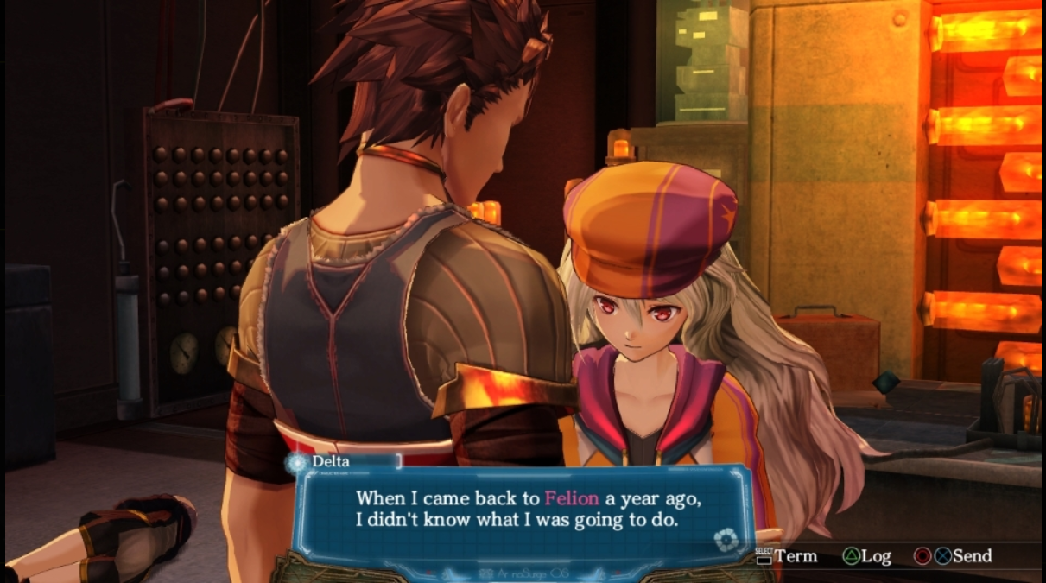
A conversation between Casty and Delta about Delta’s return to Felion after vanishing for couple months. Image courtesy of Gust Co. Ltd. All Rights Reserved.

The Interdimend is the method of literally controlling a person’s body both physically and with their voice. Gradually it will cause damage to the senses and it will eventually cause the person who originally inhabits the body to become trapped within their own body. It also allows for increased combat prowess. This is one of the major stables in the game because it will eventually come to the attention of the characters in the game that Earthes and to a lesser extent Delta are being controlled. The robot Earthes is a terminal being controlled by "someone from the seventh dimension" (the player). The characters in-game interact with you as such. Earthes only communicates through dialog prompts, the options you choose are beamed directly into the character's minds. As the story goes on, the game gets increasingly Meta with this. Eventually, a dialog prompts appear on the Delta side as well, often causing him to blurt out random lines that have nothing to do with what's currently happening.
In chapter two of the story, the character Delta will end up at a specific tower with the help of another character and attempts to disconnect the player from the control. Upon doing so, Delta will claim that he is happy to be able to enjoy his own body again. He quickly finds out he doesn't have enough power to protect everyone he cares about anymore. He ends up accepting to reinstall it because of the realization that the unknown entity has their best interests in mind, the third person perspective is helpful for the challenges ahead, and the player has access to both the Earthes and Delta channel. Delta is stronger in combat allowing him to protect the people he cares about. This realization also comes after Casty walks up and faces the screen directly in order to talk directly to the player and question them on their intention in regards to the use of Delta (her boyfriend). Delta when controlled is still his own person with his own personality, regardless of whether or not he is currently being used by the player. The decision system is what makes it odd for the other characters. Earthes on the other hand is a robot with a direct line to the player. The player is kind of, an overseer of the worlds, and the entire interface is used as if it were logging into an OS like Windows. The game actually starts with introduction programming boot commands and voice over on top of a slide-show explaining what is going on in the world. It will say things such as, that the player is given the right to intervene in this world at a specific time access point and then ending with system protocol Interdimend now being released.
Toward the middle of the game, a magic explosion occurs born out of Casty’s song magic creating a child that is also in their teens. This child named Prim eventually becomes connected to Interdimend and is connected to a being that is not the player. Late in the game, it is revealed that Prim is also being controlled through Interdimend. It is said that the "other player" has no value for the in-game characters at all and appears to be merely interested in 100% completion, and is willing to sacrifice everyone on the Soreil to do so. They also express their envy of you having access to two channels. You eventually get to thwart the "other player's" plan, preventing them from "beating the game". Instead, you are the one who gets both, to beat the game AND save the world. Whether this is because you actually care for the characters, or because this is the only route available to you, or just because it is much more fun to be the good guy, is up to you.
The story of the game outside of the 4th wall Interdimend mechanic begins with a rescue of a scientist friend named Sarly. This Sarly supposedly has a powerful song in her in her possession, a powerful Song called “Ciel N Protecta”, but it was stolen and it supposedly is the cause for the ship's guardian robots attacking Felion. The Genomoriah Church is a faction which runs a city in an inactive reactor called Quanturv. This faction is also an enemy of Felion, which is located in an inactive reactor in a city called Quanturv. During their search after locating Sarly, they find out that the leader of the faction Archbishop Zill intends to perform a powerful destructive song call Class: “Ciel_NOSURGE”. One the other side of timeline the story interweaves with other characters at very specific key points. Ion is trapped in a sealed world called a soul scape. This world where she starts at is about five minutes after the previous game “Ciel no surge” ended. That game was about Ion. It didn’t have Delta or Casty in it. At that point in time, Earthes was her helper and she decided to escape.
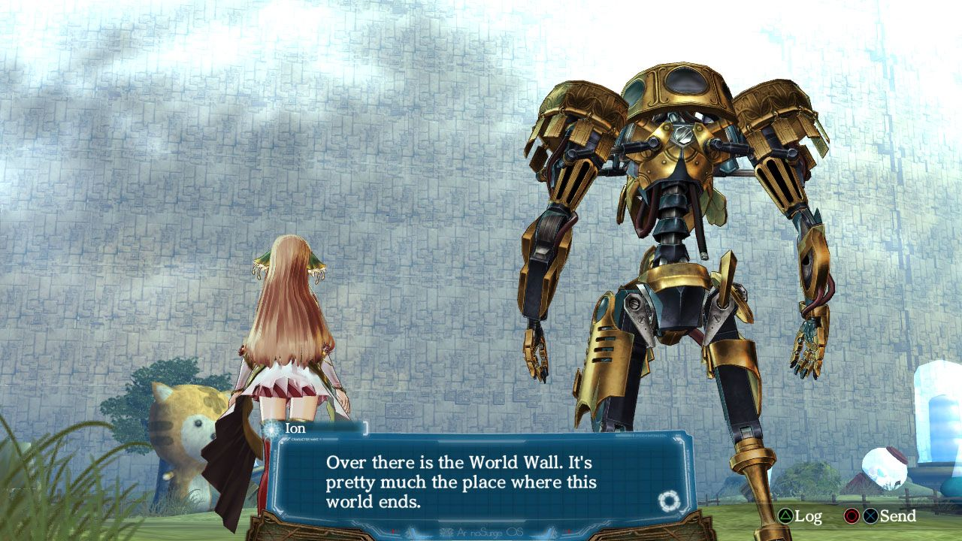
Ion viewing edge of her soulscape, before attempting an escape with Earthes. Image courtesy of Gust Co. Ltd. All Rights Reserved

Upon reaching the third city, known as the Sharyl race city called Tenryosara, the journey is concerned with seeking the truth of the world and they then eventually come in contact Delta and Casty. Behind the cheer and humor, humanity is actually stuck in a spaceship called Soreil that is roaming deep space, locked in a struggle against the Sharyl who kidnap humans. The Sharl, a fairy type race would use Song Magic similar to the Anchients as a method of capturing humans, and also as a skill that humans are powerless against. Those loved ones who are taken from residential areas by the Sharl, never return. As a result they might as well be considered dead. Diseases cause entire sections to be locked down; and what remains of humanity is divided between a religious sect that worships the Sharl, and a militant force of humans which opposes them to the death. The head of the religious sect Zill believes Sharl are the superior races and for some reason wants to rip the souls out of the humans and Sharl and form an extraterrestrial being called the Maternal Overseer. The Humans only want to not be under attack by the Sharl and are defending themselves because the Sharl always attack first. The Sharl want to coexist with the "demons” and help them achieve an enlightened life. Neither side makes a concerted effort to explain their position to the other. The Sharl have no idea of what is occurring and the reason for that is due to their leader believing that the humans will not agree. Sharl’s don’t understand humanity and with good intentions plus the will of their leader, started a war. At some point in Felion history, the Genomoriah church was a part of Felion. But, due to a conflict it broke off with the desire to coexist with the Sharl. Felion on the other hand, believed that the way to peace was through the Sharl’s destruction. In today’s time, the story falls around the player’s Interdimend controlled characters Delta and Earthes, as well as the characters such as Ion and Casty that have the ability to use Song Magic. Song Magic is a technique that the human race lost, except for just a few people, before the ship began drifting in space. The old world Ra Ciel was destroyed resulting in 5000 years of space travel before the war with the Sharl and the opening of something called the Felion wall. This wall released sleeping Anchients who lived before and during the destruction of Ra Ciel. The Anchient’s had knowledge of technology and had access to the lost song magic. Toward the end of the game it all leads to a conflict with the other place and a new song that creates the world. The song in question, comes from an event that involved seven wishes, the will of a plant and a sacrifice to become something more.
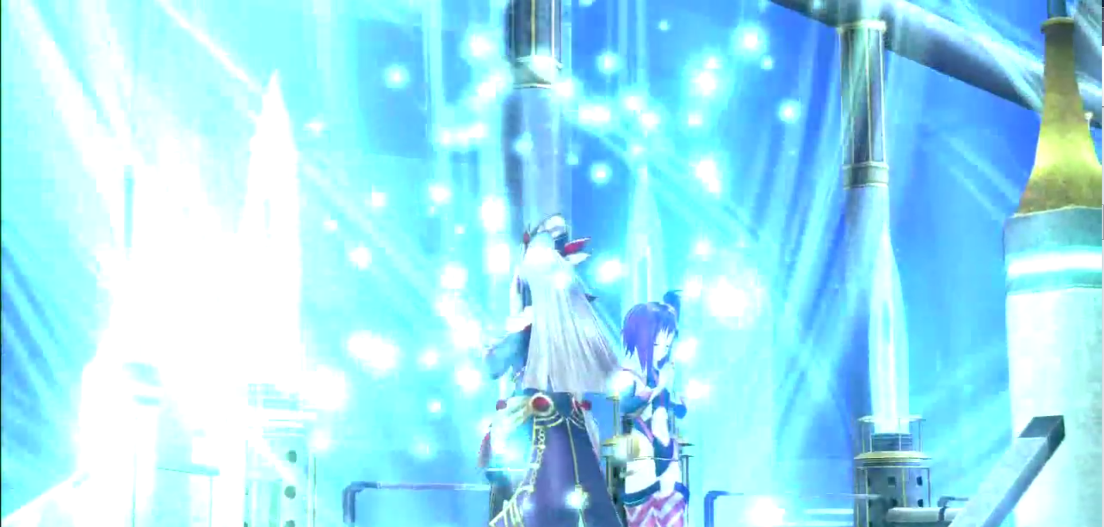
A song meant to end the war, that is capable of bringing back those who were lost in the conflict. Image courtesy of Gust Co. Ltd. All Rights Reserved.

In terms of the gameplay the story has two unique systems. The first is called a Geometrics Dive System and the second is called the Purification Ceremony System. Diving allows you to go into a virtual representation or psyche of your partner’s (or any supporting character to whom she is chained) deepest emotions and biggest personal problems that they themselves cannot solve. Starting a diving costs points and attempting to complete any event in the dive costs a different type of points.

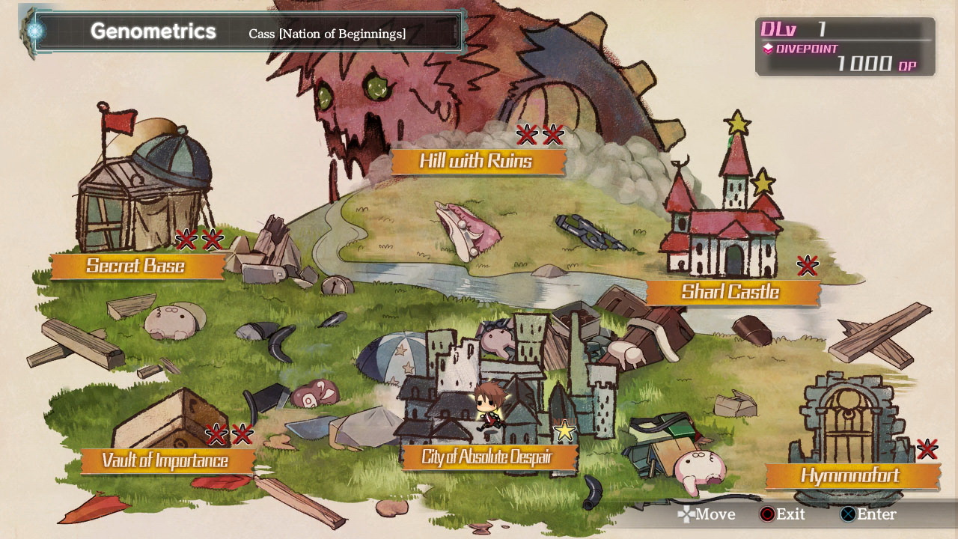
Geometric overview of one Casty Genometric maps. Image courtesy of Gust Co. Ltd. All Rights Reserved.

You complete an event and it unlocks new events. Some events can only be completed in a specific way and all of it is a collection of visual novel type gameplay with a decision system that can force you off the dive if you hit the wrong answer. Each event has different tags attached to it. A PICTURE tag has piece of CG art attached to it and a GEM tag have a Genometrica Crystals attached to them. The Genometrica Crystals can be used to advanced character statistics in a system outside the dive system called the purification ceremony where the player will get into a swimsuit with the other character. They enter the hot spring and chat with the other character, thereby raising their relationship level.
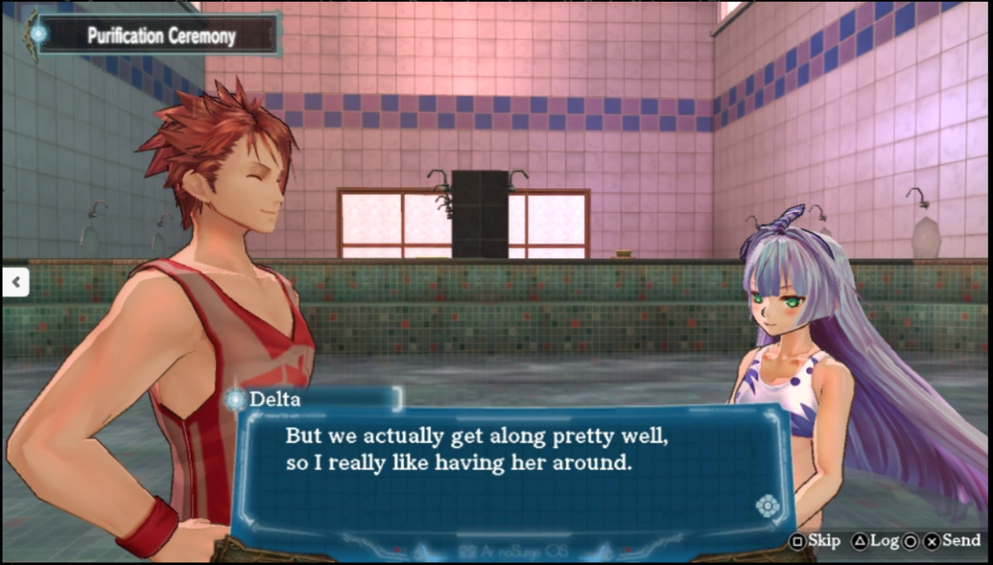
A conversation about Casty between Delta and Sarly during the Purification Ritual. Image courtesy of Gust Co. Ltd. All Rights Reserved.

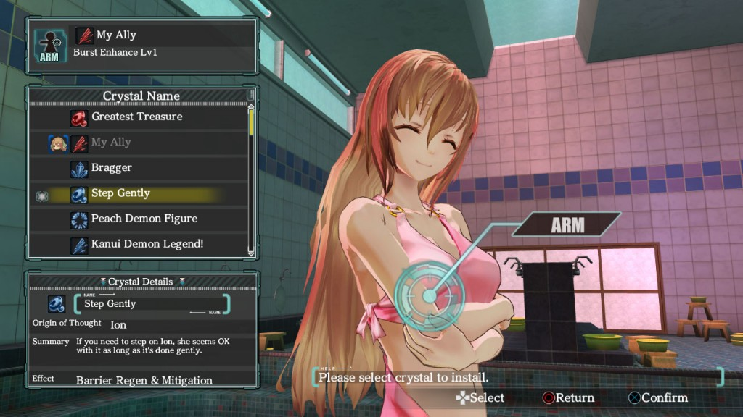
Ion’s statistics being modified through with Genometrica Crystals via an option in the Purification Ritual. Image courtesy of Gust Co. Ltd. All Rights Reserved.

As you progress in the game, more chat options open up and most stories surrounding each character are created and decision choices are provided. Back in the dive system there are also events with a songs labeled on them. At the end of each character geometric, is that song which unlocks a new song ability which can be used in combat. The more completed dives that the player does, the stronger the song magic that is created in the game. Also any choices that the players make affects the personality of the heroine. The options offered in the game in association to game actions are: Introverted (I) or Outgoing (O) and Sadistic (S) or Masochistic (M). These choices have no effect on how the player speaks in the dialog but it does have an effect on things in the combat system such as extra mitigation, increased damage or assist attacks. It also important to bring out that 4th wall mechanic again as it brings forth a series of events such as, in Ion blaming the player for treating this as a game, pressing a series buttons and for only wanting to advance. This culminates in Ion giving you a quiz of questions about her personal life you can't possibly know the answers to, except through repeating the quiz over and over until you get them right. After finally getting them right, she calls you out for Save Scumming. This leads to even more dialog questions where you can reassure her that you care for her despite her assertions being technically true, and that it's not just a game to player. This game was designed from start to finish to make the player much more than what we traditionally see in games. When the game brings up the player, it is always in a serious tone with it’s incredibly believable characters. This game stands out, as one of the finest examples of game immersion through it’s narrative without devices such as virtual reality. You the player, are a part of the Universe, and a part of this Story.
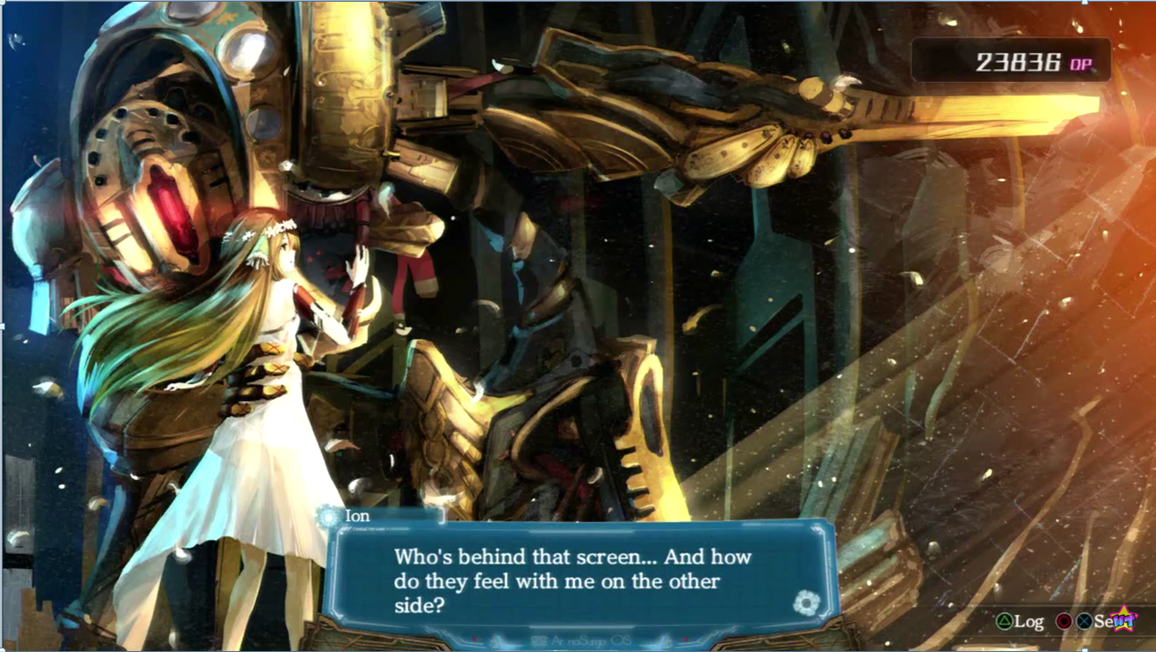
Ion in her virtual dive geometric, contemplating the player. Image courtesy of Gust Co. Ltd. All Rights Reserved.

