Chijike Dikeogu
Prof. Schmeer
English 150
September 28, 2017

Case Study 2 Hero’s Journey Analysis: Tales of Xilla 2

Developer: Bandi Namco Studios
Publisher: Bandi Namco Studios
Director: Kenji Anabuki, Asana Inoki
Writers: Naoki Yamamoto, Daisuke Kiga
Character Designers: Mutsumi Inomata, Kousuke Fujishima, Daigo Okumura
Sound: Ayumi Hamasaki, Motoi Sakuraba
Animators: Ufotable
System/Platform: PlayStation 3
Release Date: November 1st 2012 (NA), August 19th 2014 (NA), August 22nd 2014 (EU)
Series: Tales
Genre: JRPG
Rating: Teen
Introduction
Jrpg’s are games known for character development and story-driven gameplay. The game Tales of Xilla 2 was different. Normally when I play RPG’s or JRPG’s, I am filled with a touch of sadness because the story has ended and as a result, I am frequently gravitating to the MMO genre because I love story-driven games. Jrpg’s generally require hundreds of hours to finish, in order to allow the players to immerse themselves in the world and to become attached to the characters in it.
When the chance to play a continuation came around, I could only feel excitement at this opportunity. One of the big issues with continuations is that it always involves recycling in-game content such as character art, environments, cities, creatures, music and more. I personally had no issue with this because it is rather endearing and makes more sense, but I know that it can be frustrating to some people. Another issue that occurs is that the narrator in the story will spend a lot of time explaining the world to the player, meaning that the game is actually shorter for someone experiencing it for time. In addition to that, it means that the game is longer and it can also be confusing to new players because of missing details about what a known character and more. This game sequel takes place a year after the previous game and follows a different story than the previous one. In the last game, the story revolved around a character named Milla Maxwell, the successor to Lord Maxwell, the lord of spirts and elementals.
In the first game, the world was broken up into two continents divided by a single magic barrier created by Maxwell. One side that was advanced in technology used spirits as forms of electricity, sucking them out of the air to power their technology. Eventually they created a weapon that would break through the barrier, allowing them to invade and Milla Maxwell would have to stop it in order to protect the spirts. On the other side of the world, the two nations were fighting each other in the shadows under the illusion of peace. By the end of the game, the weapon is destroyed, Lord Maxwell is dead and the successor is promoted. The two nations that were fighting have fused into a single nation and both sides of the world have achieved peace.

Ordinary World / Meeting a Mentor / First Threshold Guardian
In this game, the story has the player takes control of a youth named Ludger Kresnik, who wanted to be an agent for the Spiritus Corporation, but the dialog system, regardless of which option is chosen, has him forcefully failing his test at the start of the game. He ends up mysteriously as a train station cafeteria worker a day later. Once the player leaves for work, he encounters a young thirteen-year-old girl named Elle. She joins the party for the rest of the game and her fate is intertwined with the player throughout a complicated jumble of time and space where another version of the character, Ludger, is her father. The player will also meet a character from the original game named Jude Mathis, who acts as both a mentor and a party member.
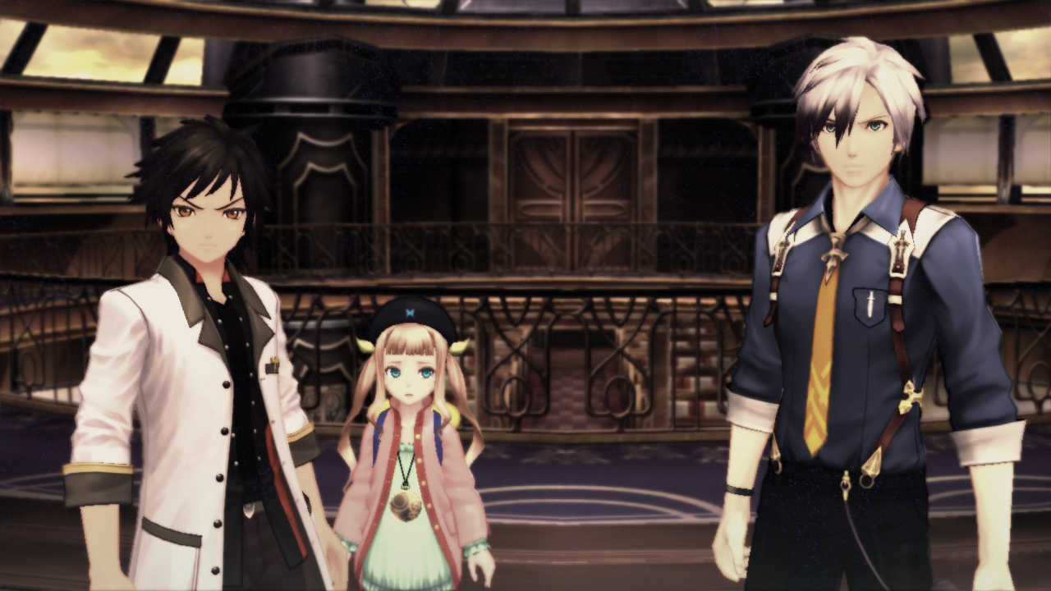
A scene from the current party from within the train. Ludger is on the right, Jude is on the left and Elle is in the center. Image courtesy of Bandi Namco Studios. All Rights Reserved.

Once the meeting with those two characters is over, the player will continue their journey to work at the train station. Upon reaching it, Elle will steal a unique pocket watch from the player. The player will be forced to chase Elle on to a train that will shortly come under siege by a terrorist group called Exodus. It is on this train that the player meets their first guardian, boss, Julius, and obtains knowledge about Ludger’s power, called Cromatis. The Cromatis has the power to close parallel worlds and it is activated by people of his bloodline coming into contact with pocket watches of the same origin. After facing off with brother Julius, the player falls unconscious and then wakes up shortly after in a bar. In this bar, the player will come in contact with the worst system I have seen in a video a game. A character named Rideaux will hit the player with twenty million dollars of debt in medical bills and force them to start repaying it for the remainder of the game.
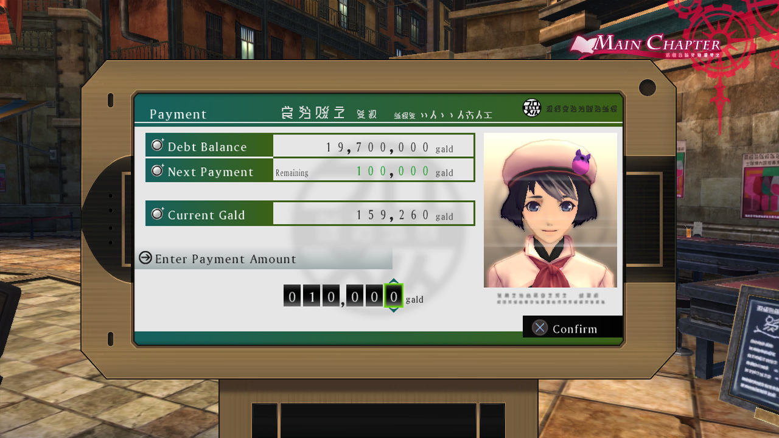
Intro fights dreams between the Ludgar and Julius. Image courtesy of Bandi Namco Studios. All Rights Reserved.
This debt system destroys the concept of side quests because the term side quest in any normal circumstance of the word is optional. Instead the debt system is a requirement in order to progress in the game. The story is then split into chapters and in order to proceed into the next town, take a train or see the next cutscene, the player has to start paying his debts in-game gold into a menu screen. The game even has an in-game debt collector that will harass or, better yet, remind the player of the debt. This causes the story's pacing to be incredibly disjointed and almost completely robs it of any impact the plot has. The momentum of the narrative is completely halted every few hours due to the necessity of grinding out menial tasks to earn money for repaying the debt. The idea of reward loses its meaning from the quest system when the player does not gain anything from it. All the best rewards come from boss creatures that tend not to give the player a lot of gold. Unlike other tales games, where the story is structured in a way the player can constantly move forward from one area to another, this one seems to have been set up using chapters which can be completed in less than 30 minutes, after which the player is locked from progressing, but only until they make a deposit to the bank.
Call to Adventure / Refusal of the Call
After coming to terms with that system, the player will eventually make it back to their apartment, where the CEO of the Spiritus Corporation makes an appearance in the player’s room. It is here that he acts as the herald for the story.
The player now has two goals. To help Elle find the land of Canaan and find Ludger’s brother Julius somewhere in the world and finding and kill Ludger, the latter which achieves both goals. The character Ludger is the brother of Julius and acts surprised during this scene when Jude accepts the call to action for you. The refusal of the call never happens because of family intervention and the threat of police intervention by the CEO of Spiritus. Ironically, that same CEO is one of the two final bosses that the players will meet in the land of Canaan.
Characters
Ludger Will Kresnik
Background: He is the main protagonist of Tales of Xilla 2. He is a silent protagonist powered by a decision system with no voice-over. He is a character that lives in an apartment with his older brother Julius and their pet cat, Rollo. He is a character doomed to being born in a bloodline that wields power capable of destroying parallel dimensions called Chromatus. Also, in addition to that unfortunate power, he also has twenty million dollars in medical bills to pay off.
Elle Mel Marta (Herald / Ally)
Background: She is an eight-year-old girl from an alternate dimension on a mission from her father to meet Ludger and have him guide her to the Land of Canaan. She has the power to take items from parallel worlds to the prime world and is the key to the Kresnik power.
Name: Jude Mathis (Party Member in Tales of Xilla 1 & 2) (“Mentor / Shapeshifter Character /Ally”)

Background: Jude Mathis is a medical student who excels in martial arts. In Tales of Xilla, he helped Milla Maxwell and the other antagonists stop a military weapon from being used on spirits and people. In Tales of Xilla 2, he has become the head of a group of scientists researching origins and he is a member of a terrorist organization known as Exodus, the same organization his father was once a part of. He joins Ludger out of curiosity shortly after meeting and fighting Ledger’s magically enhanced brother Julius on a train that was under siege by the group that he was a part of. Since he was a part of Exodus in the beginning, he does turn into a shapeshifter for the party.
Name: Milla Maxwell (Tales of Xilla 1 Hero / Tales of Xilla 2 Party Member (Ally))
Background: She is the successor to the Lord of Spirits and Elemental Maxwell. In Tales of Xilla 1, her goal was to destroy a weapon, killing the spirits. In Tales of Xilla 2, she was thrown into the void, replaced by a human individual version of Milla from a parallel world who knows nothing of Spirits. Then, when that Mila person was killed off once the original came back, she met with her in the main world dimension.
Name: Alvin Svent (Party Member in Xilla 1 & 2) (“Shapeshifter / Trickster”)
Background: He is a mercenary who distrusts others due to his parents’ relationship. He joins the party in both Tales of Xilla 1 out of interest. In Tales of Xilla 2, he joins the party because of his relationship to Jude. He also joins because he is a spy for the terrorist group Exodus and then he switches sides in favor of the party.
Name: Elize Lutus (Party Member in Tales of Xilla 1 & 2) (“Ally”)
Background: She is a 13-year-old whose parents were killed for harboring a rebellion leader called Jiao. Afterward, she was forcefully experimented on and was given a device called a booster, which augments her magical abilities. This booster takes the form of a floating, talking doll, which is also the personification of Elize’s inner thoughts. After the lab's closure, she is taken in by Jiao and chooses to leave his care to be with the party. After the events of Tales of Xilla, Elize is able to live a normal life with her caretaker and friend, Driselle Sharil. Driselle is 19 and also happens to be the lord and governor of a town called Sharilton.

Name: Rowen J. Illbert (Party Member in Xilla 1 & 2) (“Mentor/Ally”)
Background: He is a man in his sixties who was once a famous tactician, and is called the conductor. When he retired, he became a butler for the Sharil family and joined the party to stop the corruption of his old friend, who was king of the military and nation, whom he used to serve. In Tales of Xilla 2, he rejoins the party once again, and comes in contact with Jude and Elize, meaning that he joins the party once he sees the player.

Leia Rolando (Party Member in Tales of Xilla 1 & 2) (“Trickster/Ally”)
Background: She is Jude's childhood friend and a nurse who works for the Mathis family clinic. She joins the party because of Jude and because she views Mila as a role model. So her joining is for her own growth. After Tales of Xilla 2, she becomes a journalist and rejoins the party because of Jude’s presence and more or less the same reason.
Gaius Outway (Boss in Tales of Xilla 1 / Party Member in Tales of Xilla 2) (“Guardian / Ally”)
Background: He is the king of Auj Oule. His goal was to destroy the weapon’s power by the spirits and create a new system of government where leaders would be chosen on talent, skill and competence. After fighting the party in Tales of Xilla 1, he decides to unite the continent of Reize Maxia. In Tales of Xilla 2, Gaius poses as a civilian by using his birth name to investigate public opinion in Elympios. He also joins the party after being interested in the party’s goals.
Muzét (Shadow/Trickster/Ally)
Background: Muzét is a Great Spirit and Milla's older sister. In Tales of Xilla 1, she follows the party during their mission to defeat Exodus and turns against them in order to keep the existence of Rieze Maxia's barrier a secret. She allies herself with Gaius after Maxwell ceases giving her orders because of her indecisive and destructive personality. If she doesn’t have someone to guide her actions, as she gives in to despair and loses it, especially in regards to killing. In Tales of Xilla 2, in a parallel dimension, Muzét served as a party member until an event occurred where she was killed by Ludger. The real Muzét joins the party afterwards.
Antagonists
Name: Jiao (Trickster/ Shadow / Ally/ Shapeshifter)
Background: He was a rebellion leader who was sheltered by Elize's parents. Elize’s parents were killed soon after and Jiao fled, leaving Elize behind. Because of this, Jiao felt indebted to Elize and took her in. Jiao is killed during the Elympios invasion to let the party escape. Jiao is one of the 4 guardian knights that serve under Gaius in Auj Oule. In Tales of Xilla 2, in a parallel dimension version, Jiao took Elize with him instead of fleeing on his own. He switches from evil to good and back and forth. He also had a hand in destroying Elize’s childhood with medical experiments. In the parallel dimension version of him, he is killed by the player and party.
Name: Wingul (Shadow)
Background: He was the leader that opposed Gaius. Upon realizing Gaius’s potential and intentions, he decides to serve under him. He dies upon encountering the party. In a parallel dimension, he is king and not Gaius. That version of him also dies upon encountering the player and party.
Name: Agria (Shadow)
Background: She is an X-noble who went on a killing spree until she was recruited by Agria to serve under Gaius. She was killed during her confrontation with the party. In a parallel dimension in Tales of Xilla 2, she is a friend of Leia and she occasionally helps Leia with her journalism.

Name: Presa (Shadow)
Background: She is a spy for Auj Oule and falls in love with Alvin while undercover. When Presa reveals her mission to him, Alvin betrayed her, resulting in the deaths of her comrades. She is killed along with Agria during a confrontation with the party. In a parallel dimension, she is engaged to Alvin.
Name: Rideaux (Mentor/Trickster/Shadow)
Background: He is a doctor from Spiritus Corporation who saved Ludger and Elle's lives and put Ludger in debt.
Name: Victor (Herald/ Shadow)
Background: Victor is Ludger from a parallel dimension and is the father of the Elle seen in Tales of Xilla 2; He is also the primary herald and one of the two final bosses of the game. His reasoning does not quite make sense in comparison to the other characters, so I will not explain it.
Chronos (Shadow /Trickster)
Background: Chronos is one of the three original spirits and is the master of space-time. Chronos was the one who gave the Kresnik bloodline their Chromatus powers. Over the course of Tales of Xilla 2, he serves as the arbiter of Origin's examination of human worth, but quickly shows himself to be extremely biased against humans, viewing them as greedy and warlike parasites.
Name: Maxwell (Shadow / Guardian)
Background: Maxwell is one of the three original spirits and is the master of spirits. He was summoned by a human named Milla Kresnik, resulting in his fondness for humans.
Name: Julius Will Kresnik (Guardian)
Background: Julius Kresnik is Ludger's older brother. He began working for Spiritus Corporation and was responsible for killing their mother as a child during a misunderstanding. After learning about the Kresnik bloodline and the CEO of Spiritus’s goals, Julius adopts Ludger, intending to use him for revenge. Ledger’s love towards him causes Julius to treat him as a younger brother instead of a tool. Towards the end of Tales of Xilla 2, Julius offers himself as a sacrifice in order to allow the party to travel to the Land of Canaan. The player can choose to save his brother and deny the chance of entering Canaan. The result of the choice requires killing all the party members and ending the world.
Name: Origin (Guardian)
Background: Origin is one of the three original spirits and is tasked with the purification and reincarnation of souls. He arranges a trial to see if humans are worth saving and resides in the Land of Canaan where soul purification occurs.
Resurrection (back to the normal world)
The back to normal at the end of the game depends on your final decision and even then it is not necessarily normal. You can choose to save your brother, but it means killing everyone in your party. If you choose to kill your brother, you will be able to open the breech and face the final boss. After the final boss, there will be a decision where you can kill a child who has been traveling with you or the player can kill them and save the child. If the player dies, then that is apparently the game’s true ending. If the player saves his brother, then that is considered to be a bad ending. If the player kills the child, it is considered to be a normal ending. If the normal ending occurs, then the player can continue past the main story and start completing the after story quests. The player will also become the CEO of Spiritus with no visible benefit. The way this game is set up is so that not everyone acquires the chance to go home. In the saving the brother ending, the world literally ends shortly after making the player understand that it is rather pointless. As long as the player does not choose to save his brother, then they will have the chance to see cinematics at the end of the game and find out what happened to the rest of the party.

Highlight & the Strongest Element
The game has an excellent battle system, creates endearing and believable characters, and has a touching ending. The strongest element would be character development and it is even stronger if you have had the chance to play the previous game.
It is a sad day when I am more interested in completing side quests with the intent of triggering the dialog with a party member, than I am about the reward or the bosses. The idea of grinding side quests to add just a couple more words or to provide better lore seems sad, in my opinion. I do wish the developers had put more thought into creating the side quests. In all honesty, I feel as though the creation of a debt-collection system was an attempt to hide the fact that the game was either too short or the developers were running out of ideas.
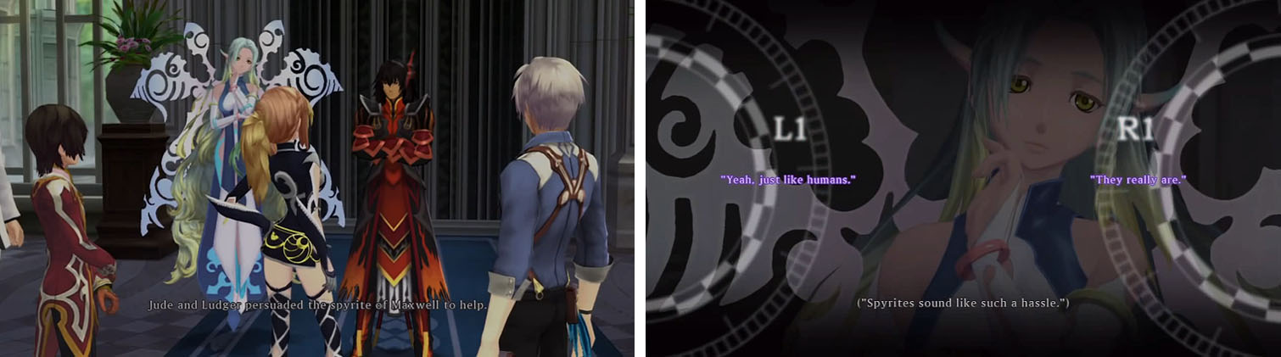
A conversation about spirits and humans between Gaius the king of Reize Maxia, Milla Maxwell, Milla’s floating spirit sister Muzet, Jude and Ludger. Image courtesy of Bandi Namco Studios. All Rights Reserved.

The Road Back
There is no chase scene in the game unless the call to adventure counts, starting from the words of the herald in the apartment at the beginning of the game. If this does count as a chase scene, then lasts a good one hundred and four hours. If the player just wants to complete the story, it will take them anywhere from thirty to fifty-six hours to finish.
Approach the Innermost Cave
The innermost cave was the land of Canaan, which was essentially a maze in another dimension where two of the original spirts resided. This was where the player had to head towards to stop the final bosses from succeeding. There is a bonus dungeon after this that has nothing to do with the story, with even harder bosses and side quest content, called the Illusionary Darkness. It is provided to the player, post-game, if the character of Ludger did not die after killing the final boss during the last decision in the game.
Supreme Ordeal
The supreme ordeal was, in actual fact, the decision that the player made at the end of the game, regarding the wish given to them by an original spirit. The player then decides how to end the game with one of three endings: they can kill Ellie for a normal ending, kill Ludger for a true ending or save Julius for a bad ending. There are six questions in the last scene after the final boss is beaten, that the player must choose from and answer, which lead to the ending.
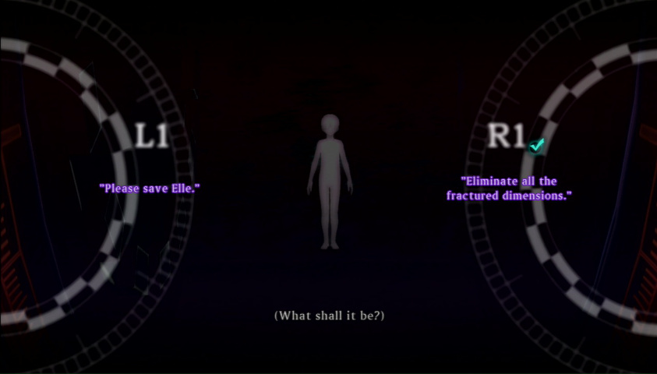
One of the series of final choices the player has presented to them at the end of the game. The character presenting these choices is named Origin Image courtesy of Bandi Namco Studios. All Rights Reserved.

Returns With Elixir

The player can be killed off and the game ends with a cinematic depending on your choices. Most if not all the side quests are already completed due to the debt-collection system. If the player chooses the normal option and not the bad or true ending, then the player is rewarded with more time to complete the ultimate bonus dungeon. That feature extends to the new game if the player decides to start the story over from the beginning. It also comes with a feature where the player can have Ludger speak some of his dialog options, but it really makes no sense as a reward at the end of the game, since it should have been something offered to the player at the start of the game instead.
Other than that, in all three endings the player will still see different cinematics of what happened based on their choices. In the normal ending, Elle dies at the age of 13 and Ludger becomes CEO of the Spiritus Corporation; it does nothing for the player at all in terms of progressing in the game. In the true ending, Ludger dies and Elle lives, regardless of which one you choose, the rest of the cast returns back to their lives as if nothing happened. If there was anything that changed, it would be that Elize starts studying under Jude at his lab.
Final Thoughts
In order to summarize this game, there are a couple things that need to be covered. The combat system remained the same from the previous game with slight improvements. The side quest was one of the killing points of the game due to it being connected to the debt-collection system. The majority of the side quests were kills or fetch quests with no real impact on the story, the world or party members. In terms of exploration, there was very little reason to properly explore the new areas players can visit, as there was no plot-related reason to do so. The number of new areas in the game is pathetically small, amounting to three new towns, a handful of field areas, and a few storyline-related dungeons, most of which players will be able to visit only once and never again.
The structure of the game felt very disjointed. The dialog was rather hollow, considering that Ludger is very close to a silent protagonist who only speaks through dialog choices made by the player. Unfortunately, very few of these choices have any effect on the outcome of the game. In the few situations where it seemed as though a choice could lead to an interesting divergence in the story, the decision was usually out of the player's hands. Players can decide to do one thing, or they can decide to do another thing, at which point in the game, the player will be forced down the first path anyway, often in the most heavy-handed of ways.

