Chijike Dikeogu
Prof. Michael John
Games & Playable Media: Systems
Dec 5, 2019

Systemic Design: The Guided Fate Paradox
Developer: Nippon Ichi Software
Publisher: NIS America
System/Platform: PlayStation 3
Genre: Roguelike / JRPG
Mode: Single-player
Introduction
The JRPG genre is known for emphasizing character development, narrative depth, and story-driven gameplay. The Guided Fate Paradox, developed by Nippon Ichi Software, stands out as a distinctive entry within this space. While it was originally conceived as a traditional JRPG, the developers chose to merge it with isometric Roguelike mechanics to challenge themselves creatively. Nippon Ichi Software, best known for its Disgaea series, created The Guided Fate Paradox to celebrate its twentieth anniversary. The company wanted the game to represent both innovation and self-reflection in their growth as developers.
Among the many systems introduced, the Burst System was the most interesting and unique feature from a systemic design perspective in my mind.
Game Overview
The Guided Fate Paradox follows Renya, an ordinary teenager who wins a “golden lottery ball” from a mysterious lottery machine at a shopping mall. The prize unexpectedly grants him the position of God, assigning him the duty of using the Fate Revolution Circuit, which is essentially a celestial machine that receives and processes prayers from mortals. This in a player context means the machine generates virtual Roguelike dungeons that Renya must traverse to fulfill the wishes of those who pray.

Throughout the game, Renya faces corrupted and self-aware manifestations of mythological, fairytale, angelic and demonic figures, such as a rebellious boss variant of Cinderella, who is attempting to escape her own looping story.
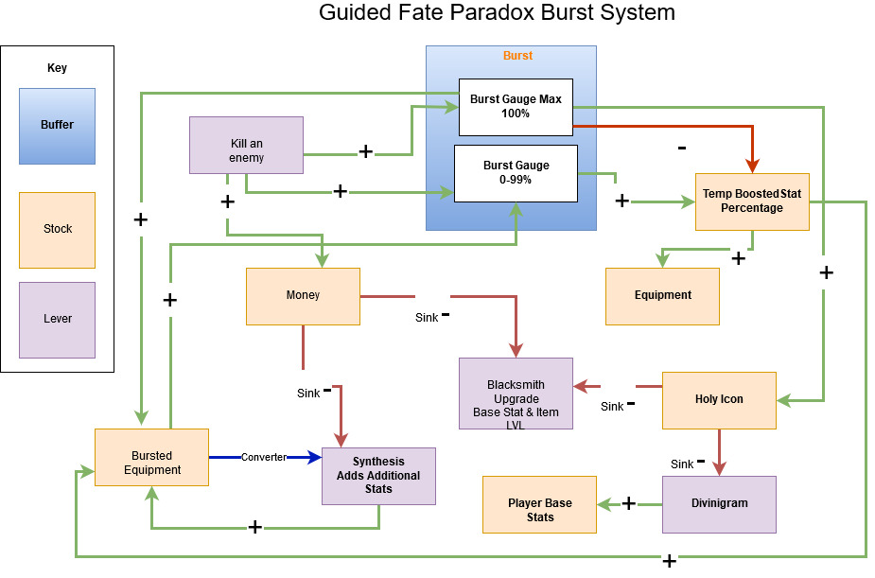
The Burst System

In The Guided Fate Paradox, the player is introduced to a new type of leveling system called the Burst System, which centers on the Burst Gauge. When the player uses a lever to defeat an enemy, the burst gauge increases by a certain percentage, up to a maximum of one hundred. The exact amount depends on the difference between the player’s stats and the opponent’s level.
If the burst gauge indicator is between one and ninety-nine percent, a positive relationship is formed between the gauge and the equipped gear. During this phase, the equipment receives a temporary stat boost. The strength of the boost depends on the current gauge percentage.
The Burst System
In The Guided Fate Paradox, the player is introduced to a new type of leveling system called the Burst System, which centers on the Burst Gauge. If the player uses a lever to kill an opponent, the burst gauge will increase by a certain percentage, up to a maximum of one hundred, depending on the difference between the player’s stats and the opponent’s level. If the indicator on the Burst Gauge is within one to ninety-nine percent, a positive relationship is formed between the gauge and the equipment, where the equipment will have its stats temporarily boosted. The boost amount also depends on the gauge number.
If the gauge reaches one hundred percent, a buffer is created, followed by both a positive and negative relationship. In the case of a negative correlation, the temporary stat boost is removed, resulting in the equipment the player is wearing being reset to the equipment’s current base stats, and the burst gauge is reset to zero. In regard to the positive relationship, the equipment that was affected by the Burst Gauge receives a status that turns it into boosted equipment, and the player will automatically receive a Holy Token.
The Holy Token can be used in two ways, and both methods are sinks. The first is by using the Holy Tokens on a system called the Divinigram, which is essentially a giant grid-style talent tree that the player can use as a lever to permanently modify base stats and ability stats at the player’s discretion.
The second way Holy Tokens can be used as a sink is through the blacksmith, who will boost equipment’s base stats if the player is willing to lose gold along with the tokens. The process of upgrading creates a positive relationship with the Burst Gauge because the blacksmith removes the burst stats on upgraded equipment, allowing the equipment to be affected by the temporary stat boost until the gauge reapplies the burst status.
The last part of the burst system is the positive and negative connection between gear with burst status and the converter through the blacksmith’s second shop, called Synthesis. If a player has two pieces of burst equipment, the player can use the burst equipment they do not wish to keep as sacrificial material on the burst equipment they want to keep.
If the sacrificed burst equipment has stats that are not on the chosen burst equipment, a portion of the new stats is moved over to the selected burst equipment, or it upgrades the base stat at a lower rate than the normal blacksmith process. Another essential factor about this system is that gold is required as a sink.
The unique thing about synthesis and standard boost token upgrades is that both processes require gear to have gone through the boosted gauge system and to have acquired boosted status before the blacksmith will work on them. The game’s character growth system is designed around lever stat choices through the blacksmith on equipment and player-specific stat choices on the Divinigram and the equipment the player is wearing. Any burst equipment that has undergone the synthesis process can have its stats increased across a range of numbers, even if the item level of the burst equipment has not been upgraded through the normal token process. However, the range of stats that players can choose to upgrade repeatedly will reach a maximum number unless the item level is increased through the token blacksmith method or a temporary stat boost is applied through the burst gauge.

